**Ahmer Aziz**

**4124**

**Assignment # 1:**

**Credit Card Payment:**

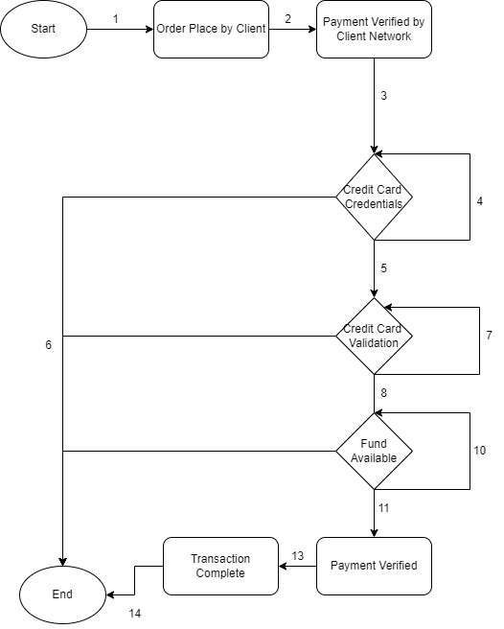

|  |  |  |
| --- | --- | --- |
| **Sr. #** | **Groups** | **Description** |
| 1 | 12,3,4,6 | Credit Card Credentials Fails. |
| 2 | 1,2,3,4,5,7,6 | Credit Card Validation Fails. |
| 3 | 1,2,3,4,5,8,10,6 | Credit Card Fund is insufficient, |
| 4 | 1,2,3,5,8,11,13,14 | Credit Card Payment Successful. |

|  |  |  |  |
| --- | --- | --- | --- |
| **Card Number** | | | |
| **EC** | | **BVA** | |
| **Valid** | **Invalid** | **Valid** | **Invalid** |
| * Integers Length=16 * Integers | * Integers Length smaller than 14 and greater than 16 * Alphanumeric * Alphabets * Symbols | * Length=16 | * Length = 15 * Length = 17 * Blank Field |

|  |  |  |  |
| --- | --- | --- | --- |
| **Item Name** | | | |
| **EC** | | **BVA** | |
| **Valid** | **Invalid** | **Valid** | **Invalid** |
| * String Length =20 * Alphabets | * String Length smaller than 0 and greater than 20 * Alphanumeric * Number * Symbols | * String Length=20. | * String Length <20. * Blank Field |

|  |  |  |  |
| --- | --- | --- | --- |
| **Name** | | | |
| **EC** | | **BVA** | |
| **Valid** | **Invalid** | **Valid** | **Invalid** |
| * String Length =20 * Alphabets | * String Length smaller than 0 and greater than 20 * Alphanumeric * Number * Symbols * First Name * Last Name * Last Name First Name | * String Length=20. | * String Length <20. * Blank Field |

|  |  |  |  |
| --- | --- | --- | --- |
| **Date** | | | |
| **EC** | | **BVA** | |
| **Valid** | **Invalid** | **Valid** | **Invalid** |
| * Month Length is between 1 and 12 * Year start from 2014 and End at 2030 * Integers. * Special Character “/” allowed. * Format mm/yyyy. | * Month Greater than 12 and less than 1 * Year Greater than 2030 and smaller than 2014 * Invalid format | * Month Start between 01/2014 and 12/2030. | * MM/YY * MM, YYYY * YY/MM * YYYY/MM * YY/MM * 12/2013 * 1/2031 * Blank Field |

|  |  |  |  |
| --- | --- | --- | --- |
| **CVC** | | | |
| **EC** | | **BVA** | |
| **Valid** | **Invalid** | **Valid** | **Invalid** |
| * Integer Length = 3 * Integers | * CVC length Greater than 3 and Smaller than 3 * Alphanumeric * Symbols | * Integer Length = 3 | * Integer length =2 * Integer Length = 4 * Blank Field |

|  |  |  |  |
| --- | --- | --- | --- |
| **Amount** | | | |
| **EC** | | **BVA** | |
| **Valid** | **Invalid** | **Valid** | **Invalid** |
| * Amount Length between 1 and 100000 * Integers | * Amount length Greater than 100000 and Smaller than 1 * Alphanumeric * Symbols | * 1 or 100000 | * 0 or 100001 * Blank Field |